# **Logo, icon Description automatically generatedLogo, company name Description automatically generatedTUllOw C.s Match report**

T.C.S U19s Girls make it a magical FINAL Win!!

***Reporting by: Emma Jordan & Robyn Sherratt -Active School Flag Reporting Team***

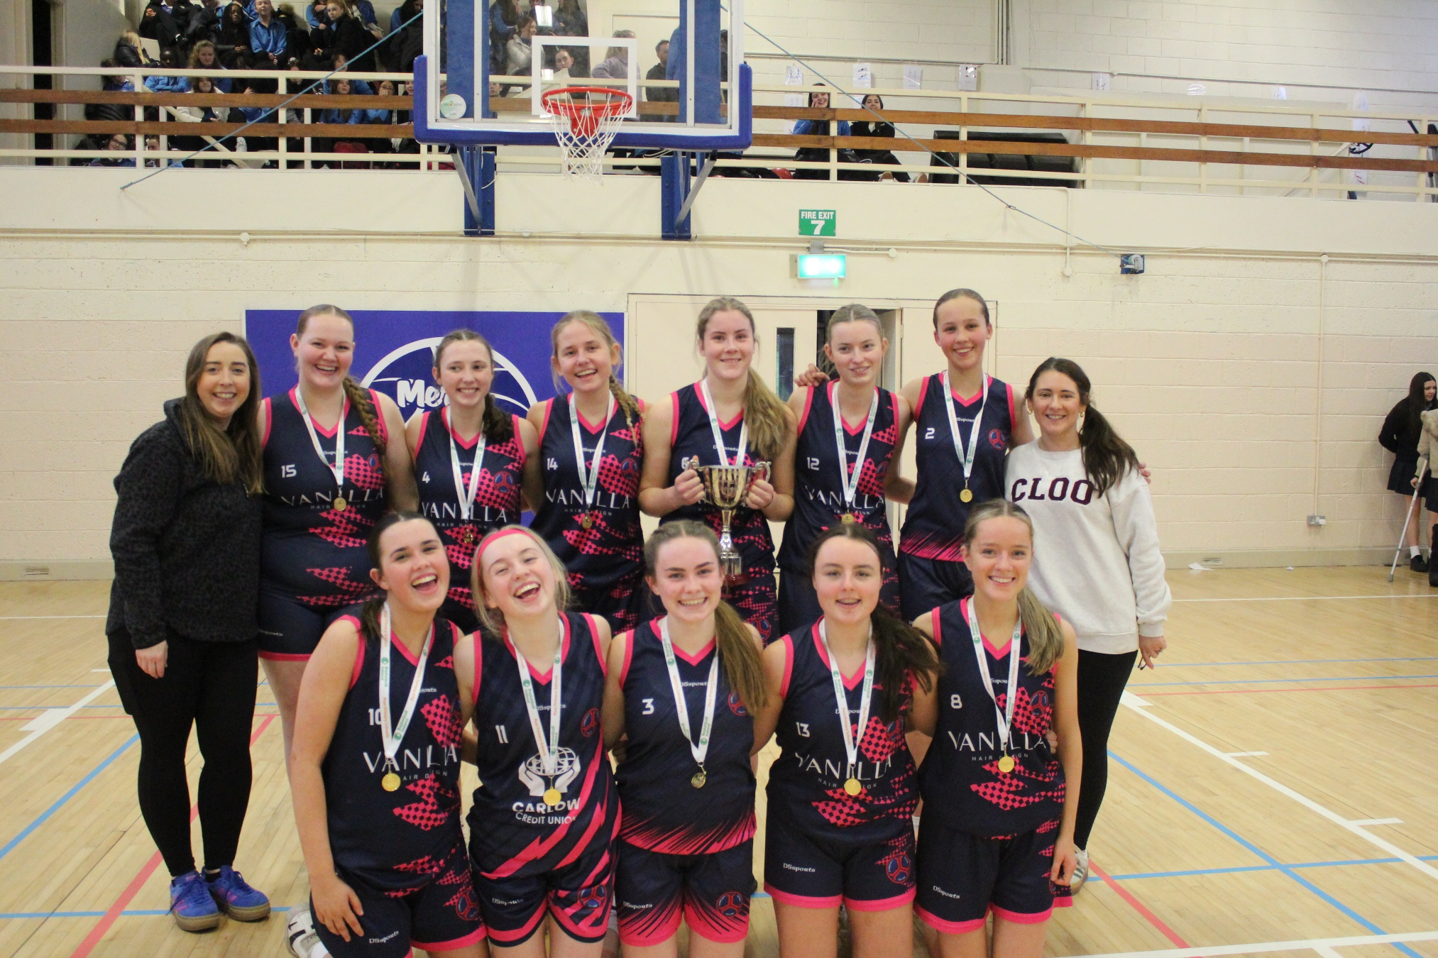

On Tuesday the 10th of December the Tullow CS U19 Girls Basketballers along with their coaches Ms Roberts & Ms O’Hara travelled to Mercy Secondary School in Waterford to take on CI Clonmel in U19 Leinster Regional Final. In the second of what was a double header of finals for the school on the day with the U16 Girls having already won their final with a great team performance the U19 grils were determined to make it a day to go down in history for the school and bring home two cups.

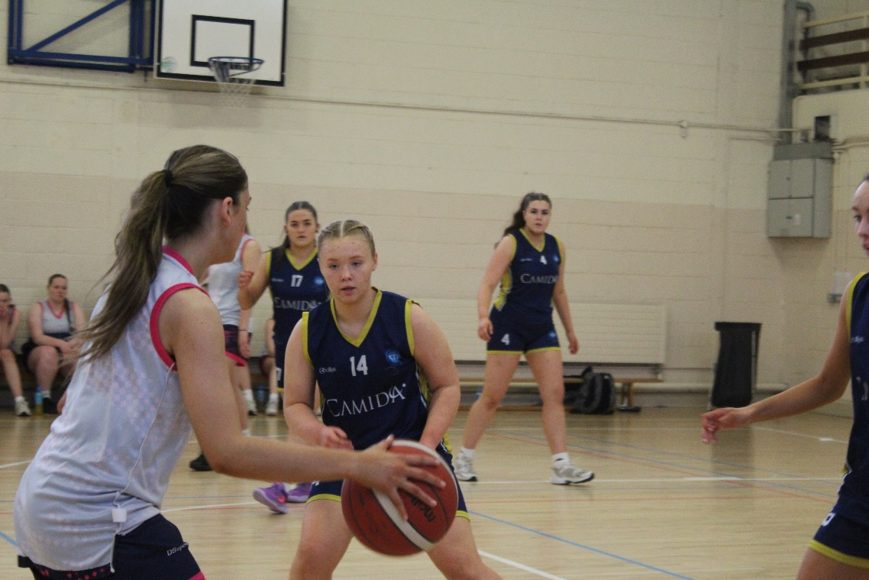 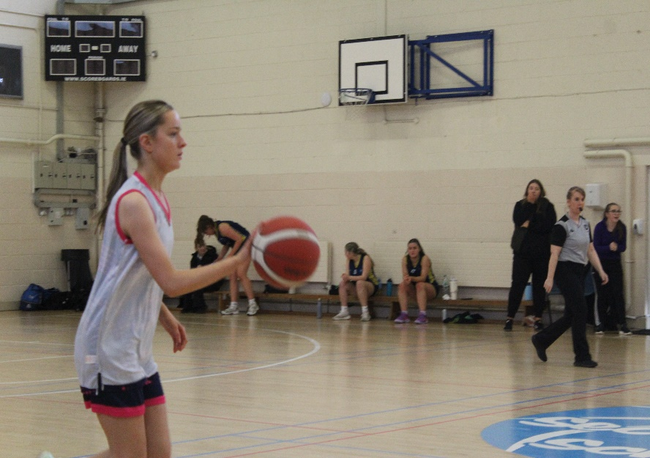

As was to be expected with some much to play for the opening quarter was a tight and cagey affair with both teams working hard in possession and defence and leaving scores to be well earned. Orlaith Healy and Allie McDonagh were giving the Tullow team plenty of energy up and down the court and team captain Aoife McFarland was on hand to covert the few chances that came the Tullow sides way. Clonmel were always quick to answer any Tullow score and the first quarter came to a close with the game tied.

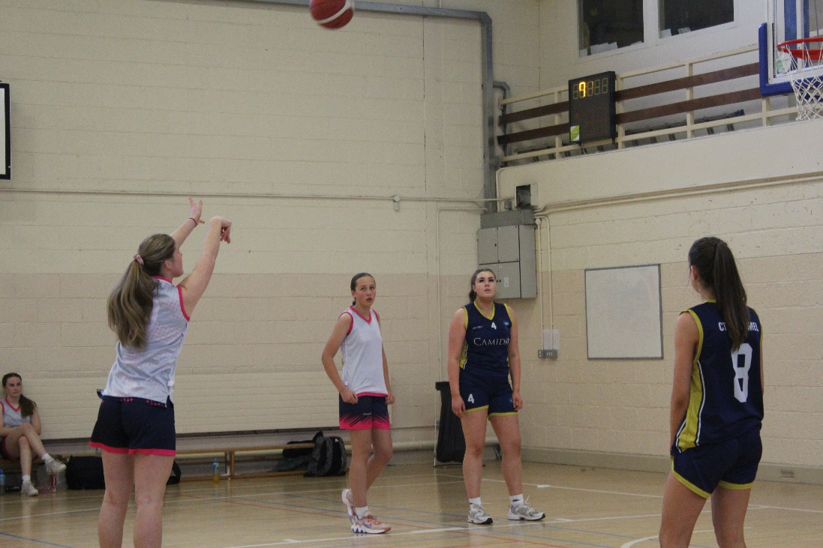

Having already played an instrumental part in the U16 girls final win earlier in the day the second quarter seen Ciara Cahoon show great maturity as she scored a stunning 3 pointer from outside the arc to spur her team on and push the TCS girls into a narrow lead. The CTI Clonmel responded well do and a couple of baskets seen them edge back in front in what was becoming a very close back and forth game. Aoife McFarland was on hand again to score for the Tullow girls and as the halftime whistle sounded the game was perfectly balanced between the sides.

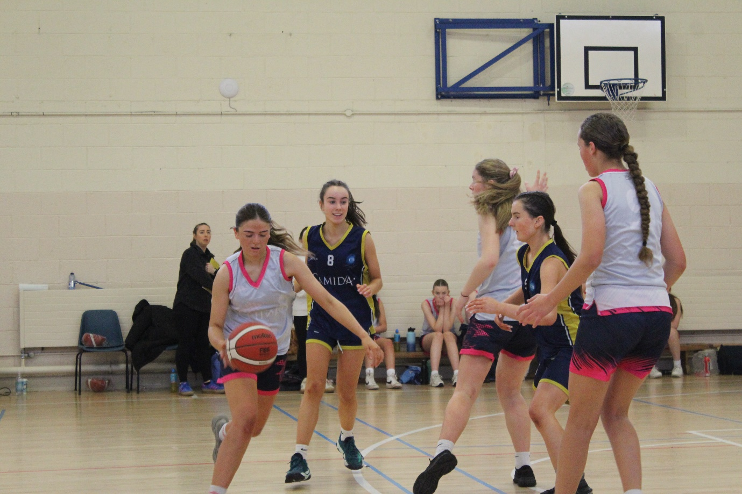

After a well-earned break and a team talk with Ms Roberts & Ms O’Hara the girls took to the floor for the third quarter. It was the Clonmel sides turn to apply the pressure now and a quick start seen them push ahead on the score board. The TCS girls dug deep do and Lyn Walsh and U16 captain Katelyn Dempsey put in a massive effort to pull the girls back into the game. Ms Roberts was happy to rely on the quality of her whole squad and Eabha Maxwell, Sine Myers, Katie Keegan, Arta Pilmane & Orlaith Donoghue all played their part in the second half to bring fresh legs and intensity when needed.

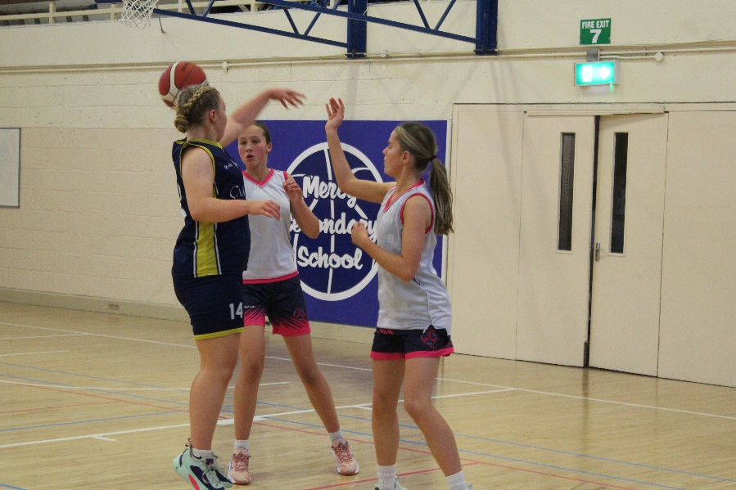 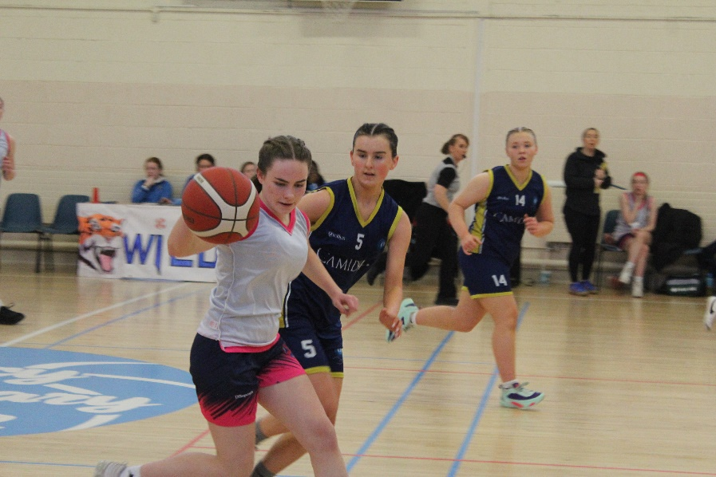

The fourth quarter began with the sides all square and the nerves & tension was palpable. Both sides knew that it was all to play for in this final quarter and the intensity of play really picked up. However, it was the Tullow Girls who dug deepest and just when it seemed like the game was heading to a grandstand close finish TCS captain Aoife McFarland and Ciara Cahoon put on a brilliant scoring display and all of a sudden the Tullow lead was out to 7. The girls never let up and despite the valiant efforts of the Clonmel side the final whistle sounded in this epic match with the score 41-32 to TCS. Well done to both team on a brilliant game and massive congratulations to the TCS Girls and their coaches for making it a historic day for school sport and one to live long in the memories!!

