# **Logo, icon Description automatically generatedLogo, company name Description automatically generatedTUllOw C.s Match report**

T.C.S U16s Girls Triumph in bIG FINAL Win!!

***Reporting by: Emma Jordan & Robyn Sherratt -Active School Flag Reporting Team***

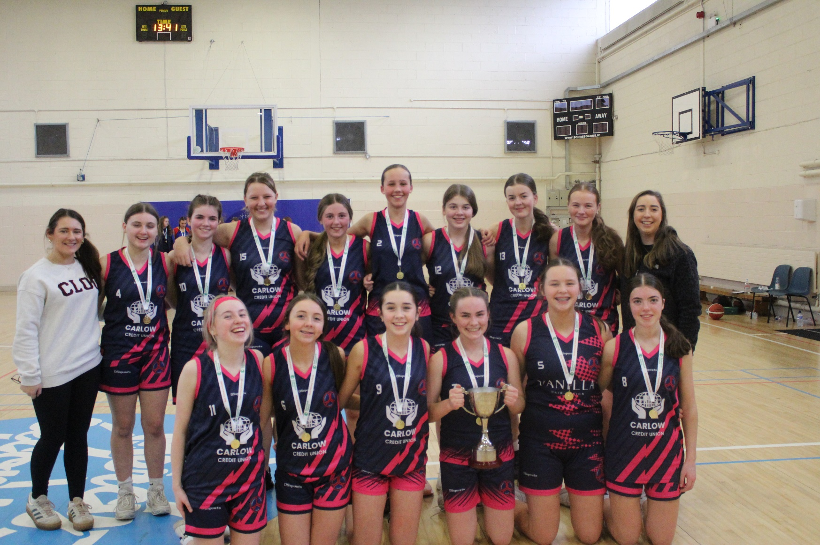

On Tuesday the 10th of December our TCS U16 Girls Basketballers travelled to Mercy Secondary School in Waterford to take on Colaiste Eoin Hacketstown in U16 Leinster Final. In the first of what was a double header of finals for the school on the day with the U19 Girls to follow in their own final later, hopes were high that the junior girls could lead by example and bring home the cup.

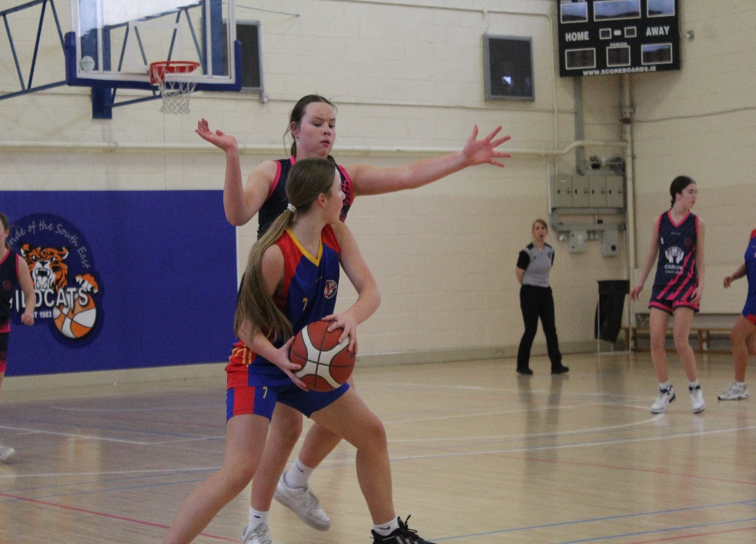 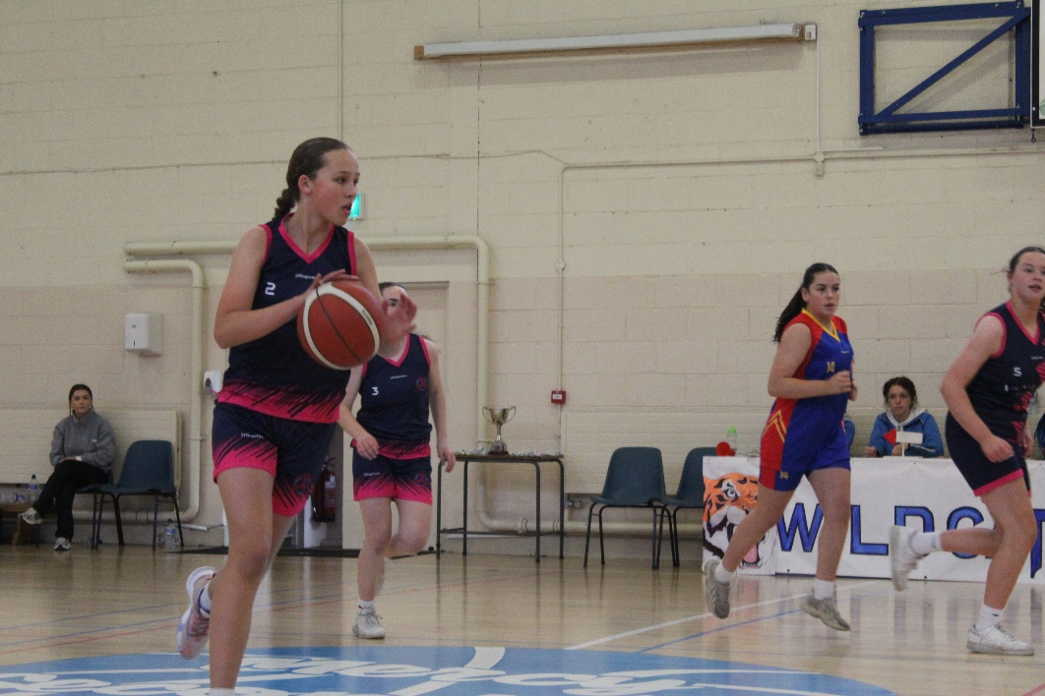

The girls knew this would be a tough match but were determined to start fast and that’s exactly what they did when Ciara Cahoon was on hand with the first basket of the game to set the tone for the first quarter. With Mia Nolan and Katelyn Dempsey getting up and down the court the Hacketstown girls were struggling to deal with the early intensity from TCS. A very good first quarter was rounded out for the Tullow side when Una McFarland hit two baskets and left her side in a good position heading into the second quarter.

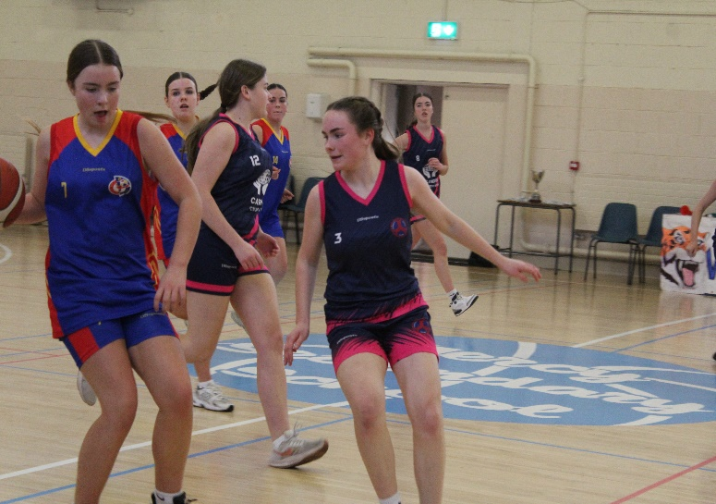 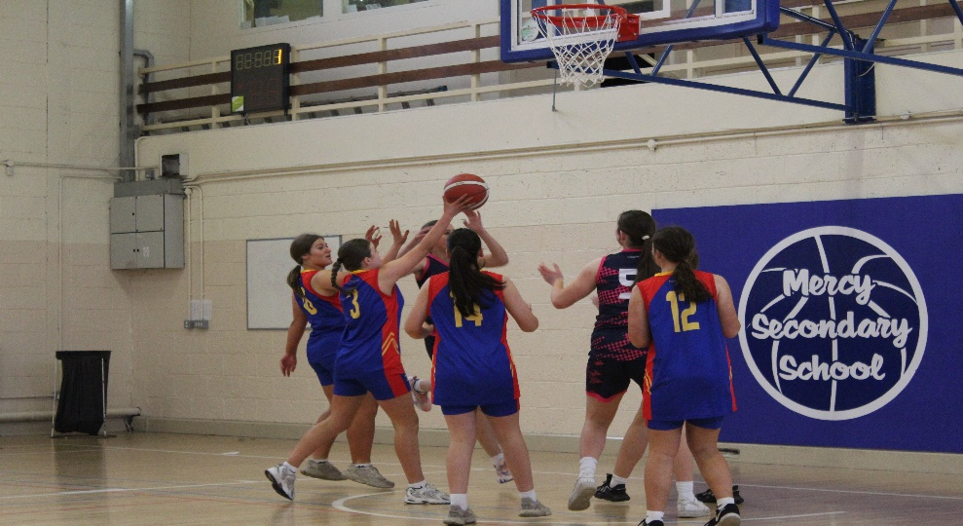

The Colaiste Eoin girls used the break to compose themselves and showed great spirit to work their way into the game in the second quarter. TCS had to rely on some excellent defence from Ella McDonald and Caoimhe Dempsey to keep themselves ahead in the game. This teamwork paid fruit as this solid defence allowed Una McFarland and Ciara Cahoon to pop up again with a couple of crucial baskets each to maintain the Tullow lead as half time approached.

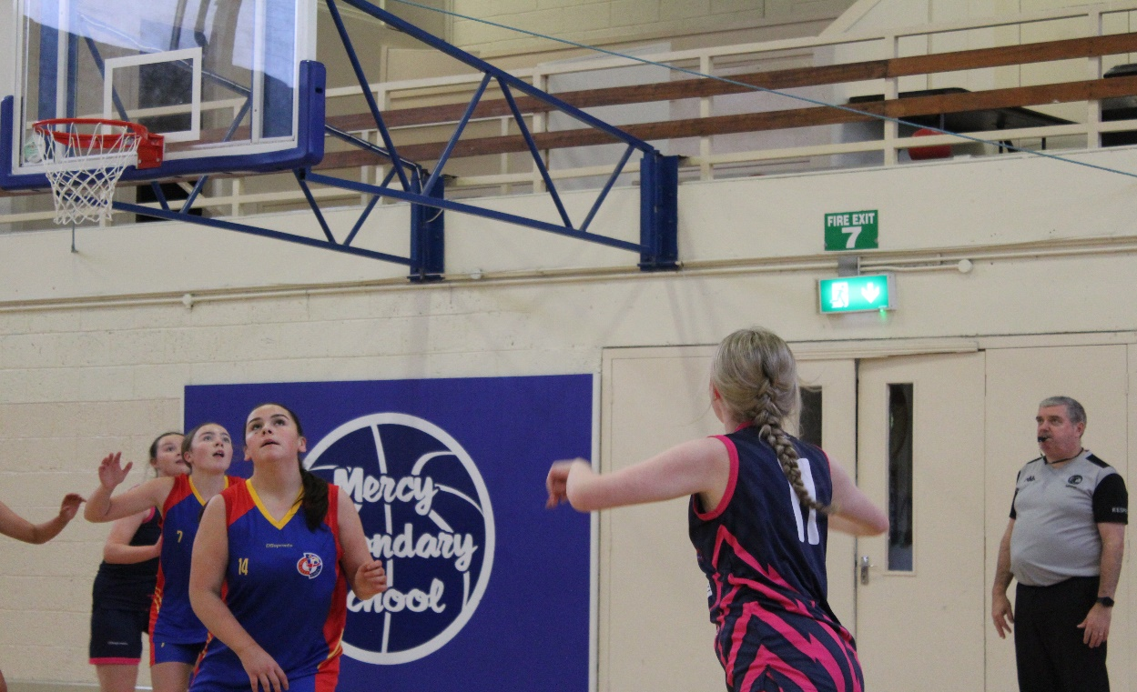

Ms Roberts & Ms O’Hara gave the girls a great halftime team talk and the message was clear keep up the same work in the second half and be ready for a Hacketstown fight back. Alanna McCarty and Kate Byrne were working tirelessly as the third quarter progressed and this work rate helped to nullify the Colaiste Eoin fight back. As the third quarter progressed the TCS side tried to push home their advantage and baskets from Mia Nolan and Caoimhe Dempsey helped to do this.

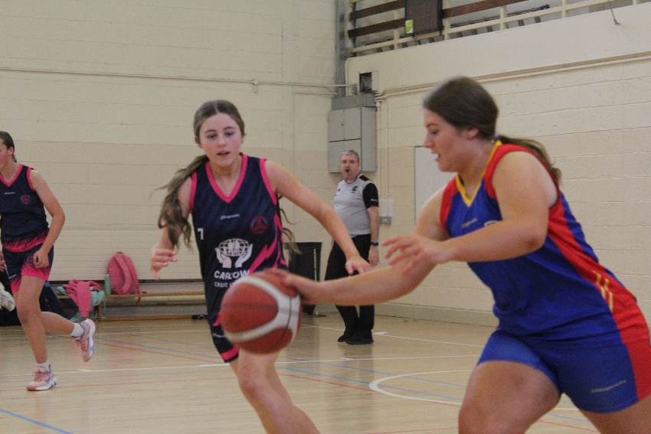 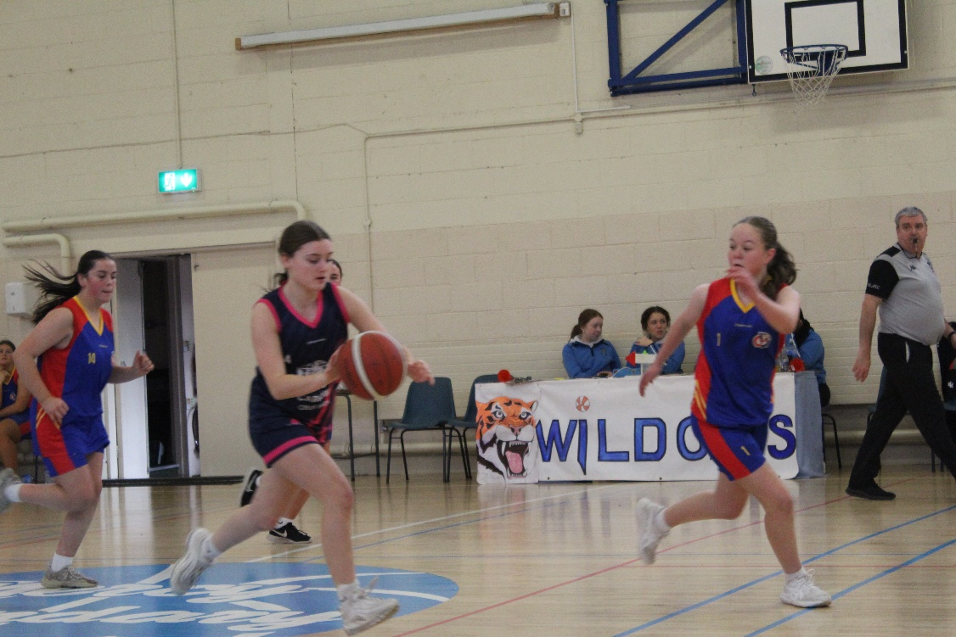

As the fourth quarter began the Hacketstown side showed great heart and determination to bring the game to Tullow and looked to close the gap. The Tullow squad all did their part in trying to keep the Colaiste Eoin advance at bay and Chloe Davis and Katie Kelly added great energy to the team. The TCS girls had to really focus to see out the win but some great team passing and concentration helped to see them come through with a convincing win on a score line of 26 to 9. Well done to both teams on what was such a well contested Final. Hugh congratulations to the TCS Girls on such a brilliant win and a massive thanks to their coach Ms Roberts for all her time & dedication throughout the year and to Ms Smyth & Ms O’Hara for all their help!!

