# **Logo, icon Description automatically generatedLogo, company name Description automatically generatedTUllOw C.s Match report**

*T.C.S JUNIOR GIRLS UNFORTUNATE IN BIG GAME*

***Reporting by: Luke Evans & Oliver Dyl -Active School Flag Reporting Team***

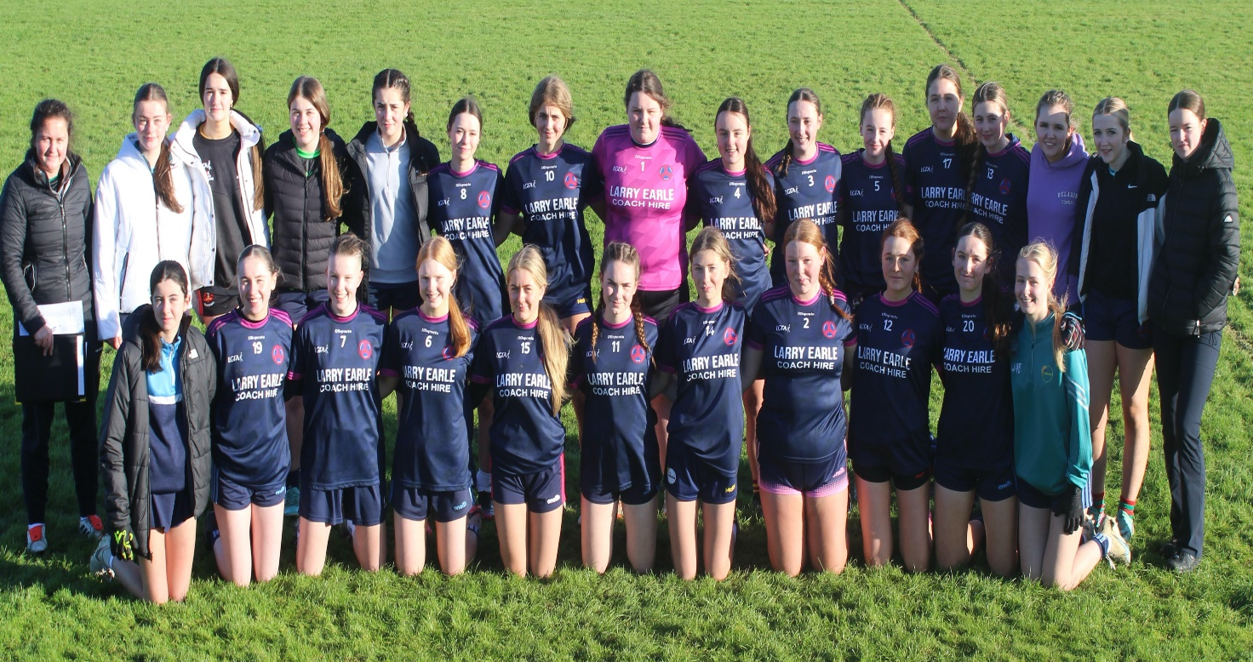

On Monday the 2nd of December Tullow Community School’s Junior Girls Football team took on Mountrath Community School at home on the TCS pitch. In what was a must win game for both sides a quick started was needed by both teams but it was the Mountrath girls who got it. Having won the throw in they were quickly into the pace of the game and notched two early points on the score board. Playing against a strong wind the TCS girls were battling hard to progress the ball through the lines and had to rely on a couple of excellent saves from goalkeeper Abbie Keppel to save them going further behind.

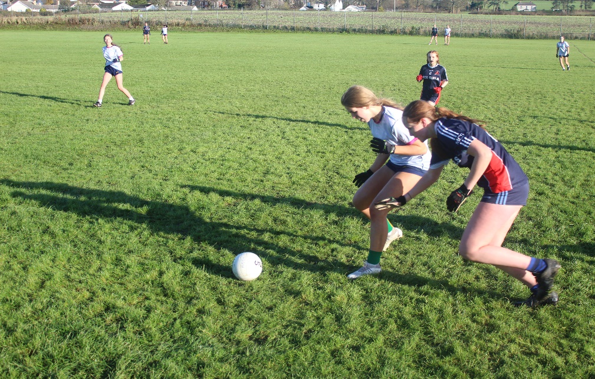

However, despite her best effort the Tullow goalie couldn’t hold out the Mountrath forwards forever and a deflected shot midway through the half eventually seen the MRCS side get their goal. The TCS side didn’t drop their heads and fought back well to quickly reply with a point of their own but a late Mountrath surge in the second half seen them pick off four unanswered points to leave the halftime score at 0-01 to 1-06.

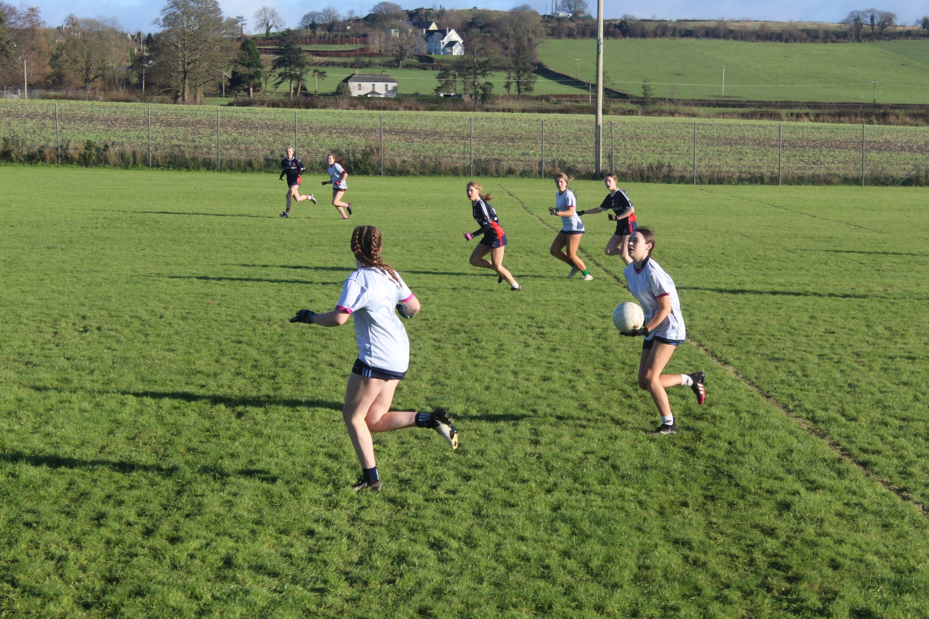

After a good team talk from Ms Walsh at halftime the Tullow girls came out fighting in the second half. TCS looked like they were back in it, scoring 2 points in quick succession to close the gap on the scoreboard. This game was now very finely balanced and midway through the second half the Tullow side got a lifeline with a yellow card and ten minute sin bin for a MRCS forward.

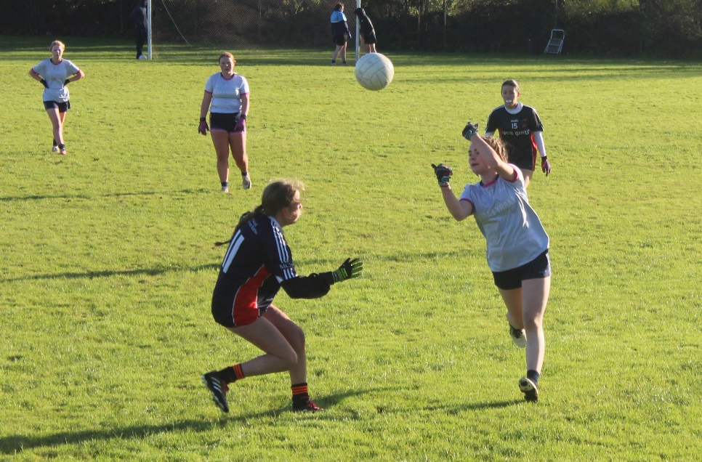

The home side were on the front foot now and were rewarded for their fighting spirit with a goal soon after. To their credit the MRCS girls pushed back by scoring two points of their own and with 15 minutes left there were only 5 points in it. Another fine save in the TCS goal from Abbie Keppel save and another point for the Tullow girls at the other end had the home fans hopeful for a dramatic finish. It wasn’t to be however as the Mountrath side kept their composure and seen out the game with another goal and a point to leave the final score at TCS 1-04 to MRCS 2-09. Well done to all players & coaches for an entertaining game of football. Notable performances for TCS came from Mia Nolan, Abbie Keppel and Katelyn Dempsey.

