# **Logo, icon Description automatically generatedLogo, company name Description automatically generatedTUllOw C.s Match report**

Emphathic win for Tullow senior boys

***Reporting by: Callum Boland & Noah Cullen -Active School Flag Reporting Team***

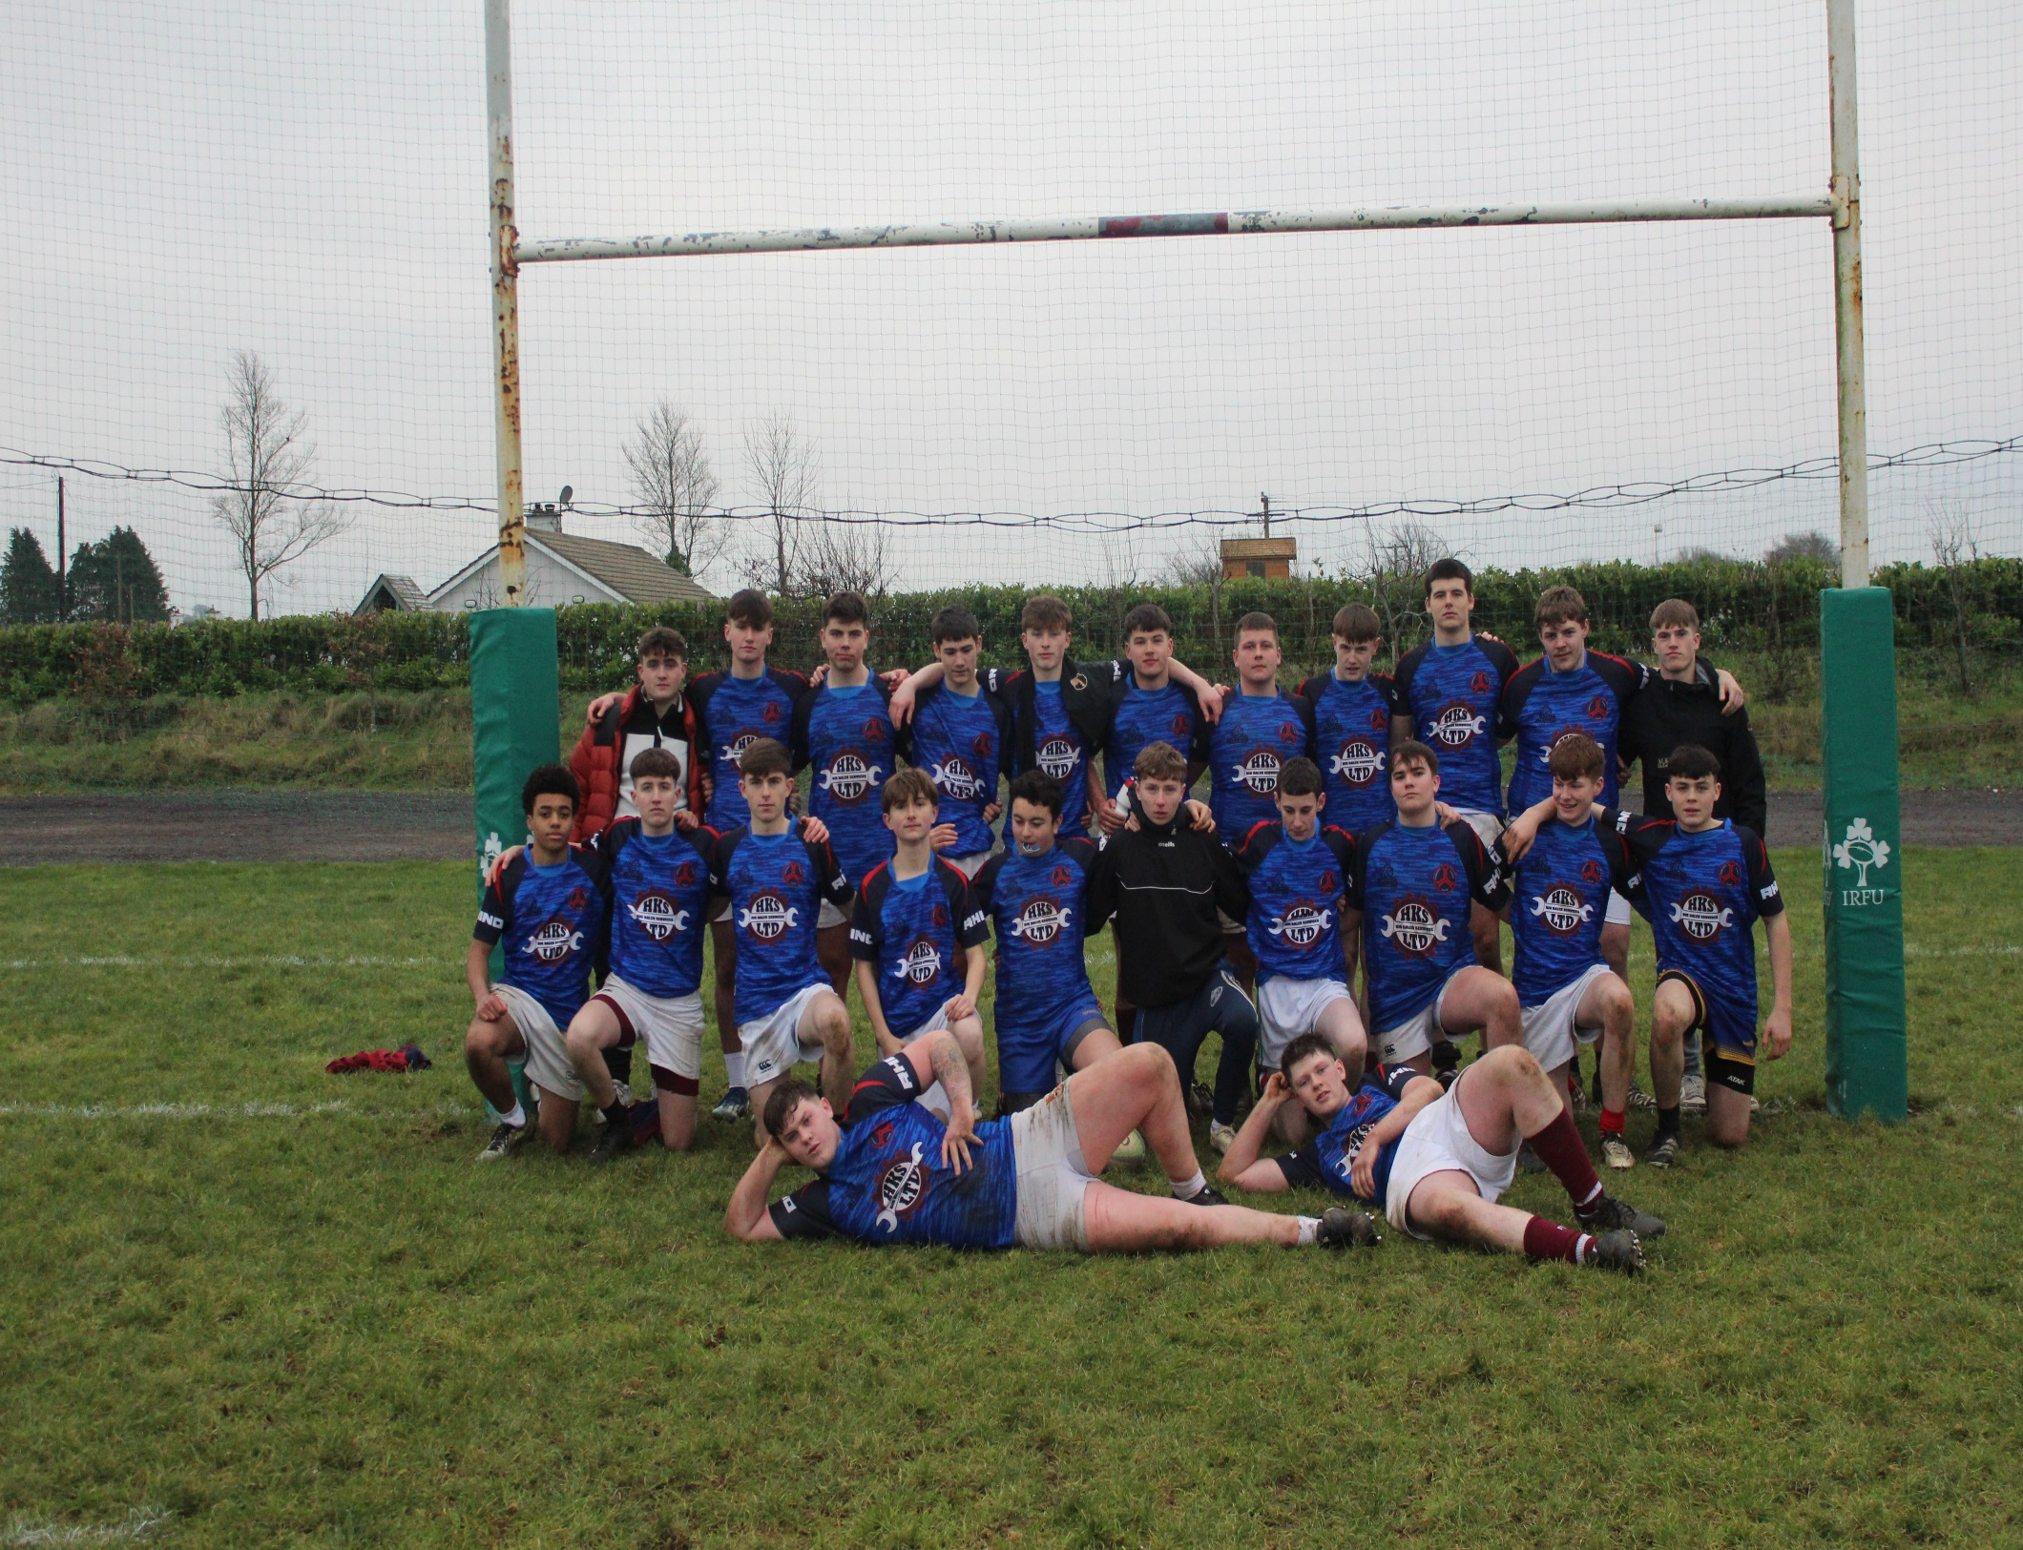

Tullow CS Senior Boys Rugby team took on Patricians Secondary School Newbridge in the Leinster Senior Cup at Tullow RFC grounds at the black gates on Thursday 12th of December. Played in good conditions a game that would eventually turn into a Christmas cracker had a cagey start. Both teams were probing for territory and testing out each other’s kicking games.

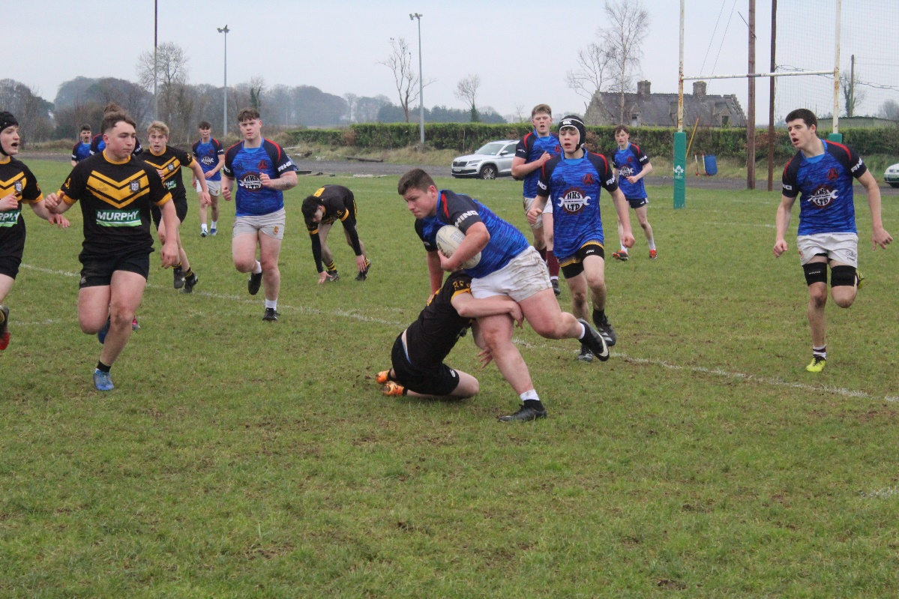

It took a great try by Jacob Sherlock to eventually break the deadlock and register the first score of the game. Out half Daragh Butler followed up with an outstanding conversion that wouldn’t be out of place in the Aviva Stadium to give Tullow a 7-point lead. The lead didn’t last long however as this Tullow try seemed to spur the Newbridge side into action and they soon responded with a converted try of their own to level the score at 7-7.

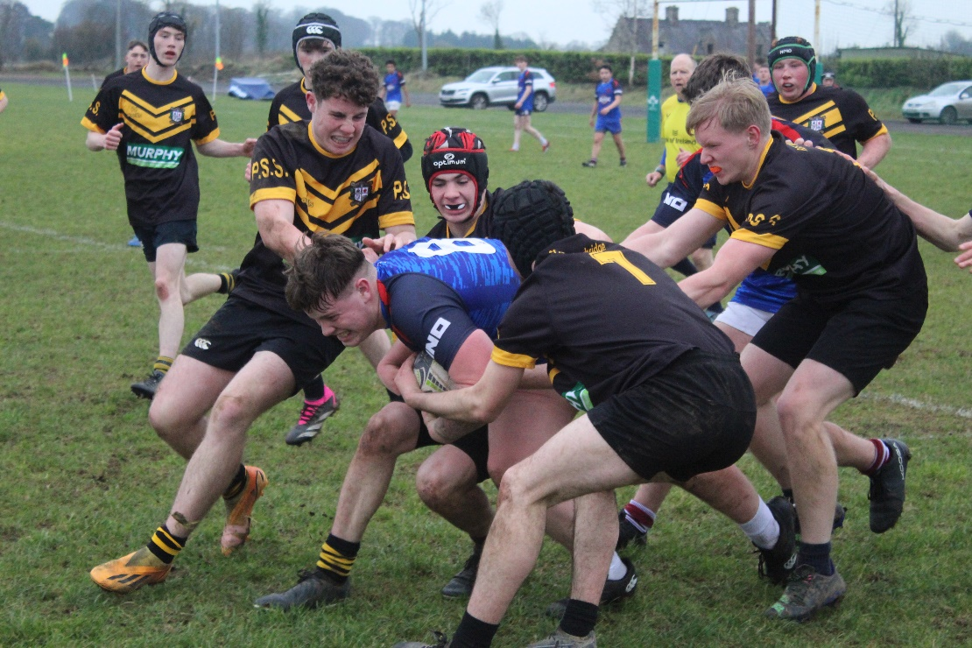

Tyreese Kavungu on the Tullow wing was beginning to cause problems for the opposition and he combined with Jacob Sherlock to create Tullow and Sherlocks second try of the game which Butler duly converted again. The back and forth nature of the game continued do as similar to the first score Newbridge immediately responded with a try of their own but this time the conversion was missed leaving the score line at 14 points to 12 in TCS’s favour.

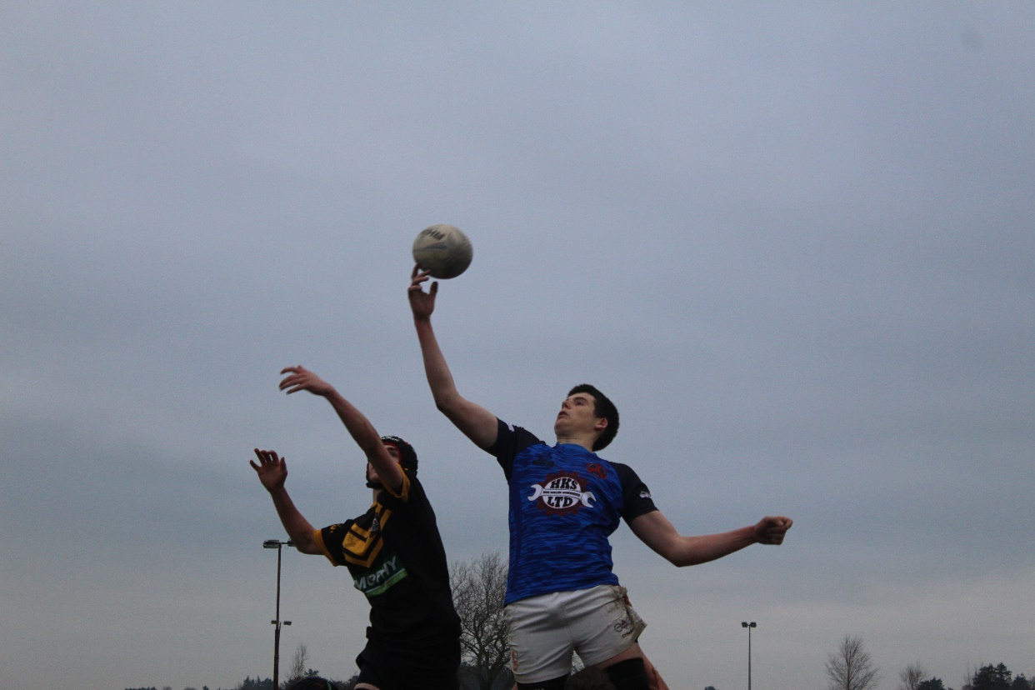

Tullow rallied well and really found their feet pinning the opposition inside their 22 but just as it seemed another try was inevitable a turn over ball released the Patricians winger for a breakaway try and just like that the momentum was back with the Newbridge side.

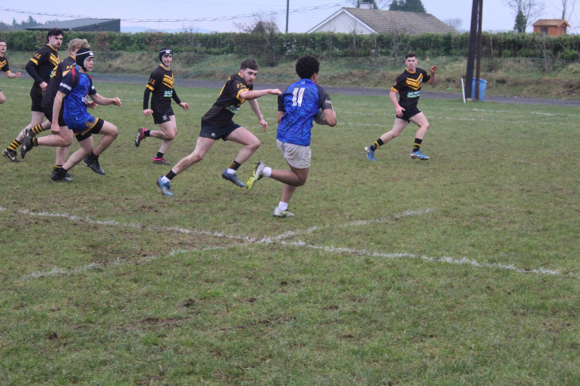

However, Tullow didn’t drop their heads and inspired by their No.8 Senan Keating he went through the phases and eventually barrelled over the Newbridge line to once again take a slender lead. The game was so finely balanced now it seemed both sides knew a mistake or moment of brilliance could be definitive. It seemed like it was going to be the former when a TCS mistake gifted the Newbridge side their fourth try of the game with a successful conversion following to leave the score at 24-19 with minutes to go.

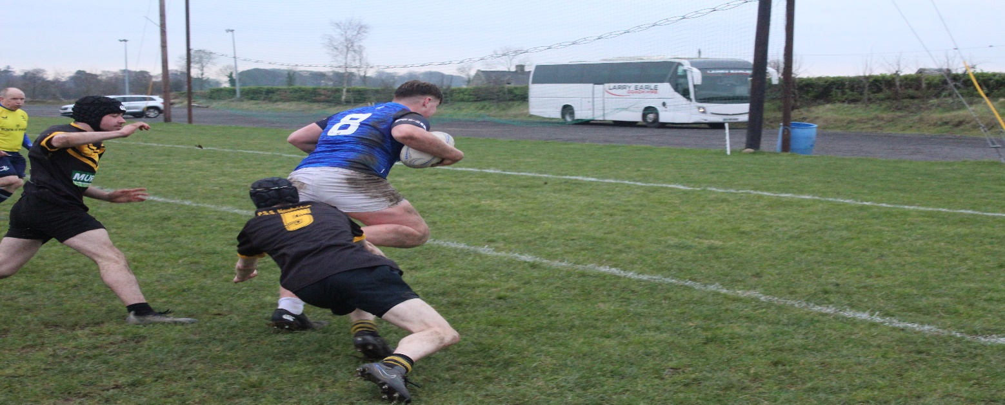

Yet again when his team needed him Man of the Match Senan Keating stepped up and rolling off the back of a TCS ruck he powered his way through four Newbridge defenders to cross the line and draw the game at 24-24 all. With time about to run out Tullow made one last push and their never say die attitude was rewarded when Jack Nolan sent the how side crazy as he barged over the line to score a last minute winning try. Both teams and their coaches must be congratulated on a fantastic game of rugby with Tullow CS just winning out on a score line of 29 -24.

