# **Logo, icon Description automatically generatedLogo, company name Description automatically generatedTUllOw C.s Match report**

T.C.S U19 boys WIN BIG Again!!

***Reporting by:***  ***Daniel O’Brien & Patrick O’Toole-Active School Flag Reporting Team***

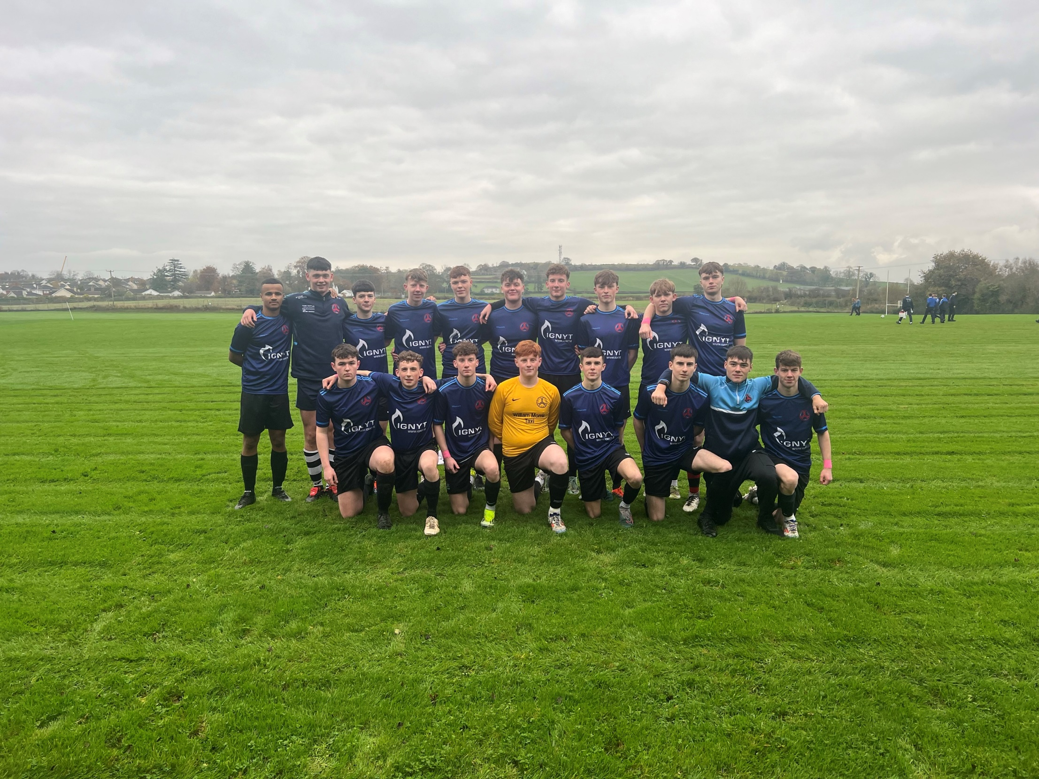

On Tuesday 19th of November the U19 Boys welcomed Scoil Chonglais Baltinglass to the TCS pitch for the 3rd game of the group stage. On a wet day with difficult conditions under foot the game started quietly with both teams trying to find there feet in a very even and closely contested opening. TCS were the first to go close to opening their account with a missed goal opportunity from Aaron Dowling that brought a good save from the Baltinglass keeper in the 12th minute.

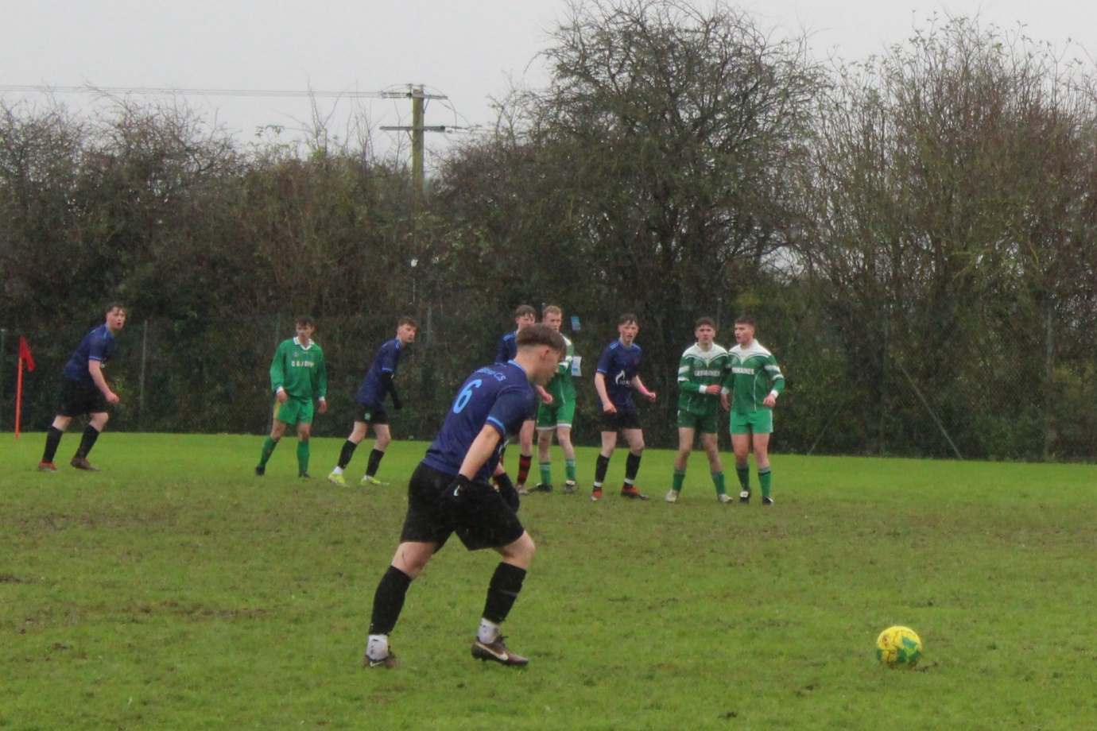

Despite the early Tullow pressure it was Baltinglass who broke the deadlock when in the 15th minute then broke on a quick counterattack to gain a surprising 1-0 against the run of play. The TCS lads didn’t let this t back affect their play and continued with the early pressure they had been applying. This bared fruit when Adam Clearly got behind the Baltinglass backline and found the net with an absolute rocket of a shot to draw his side level in the 19th minute.

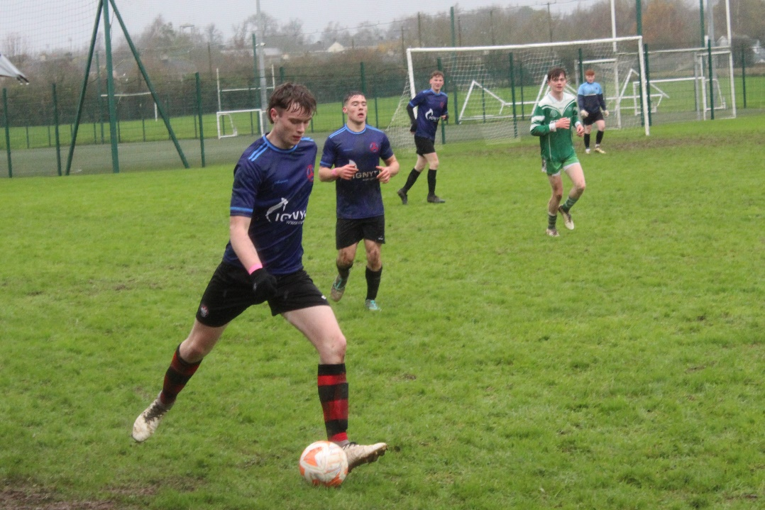

Tullow continued to dominate the game and when the Baltinglass goalkeeper was forced to bring down the on rushing Callum Murray a penalty was awarded in the 27th minute. Aaron Dowling stepped up to the spot and he cooly & calm slotted it home to push Tullow into the lead once more. Tullow nearly doubled their lead in the 39th minute when a lovely cross by Jamie Maher which sailed into the box and was narrowly missed by the oncoming Tullow attacker. Half time score is 2-1 to Tullow.

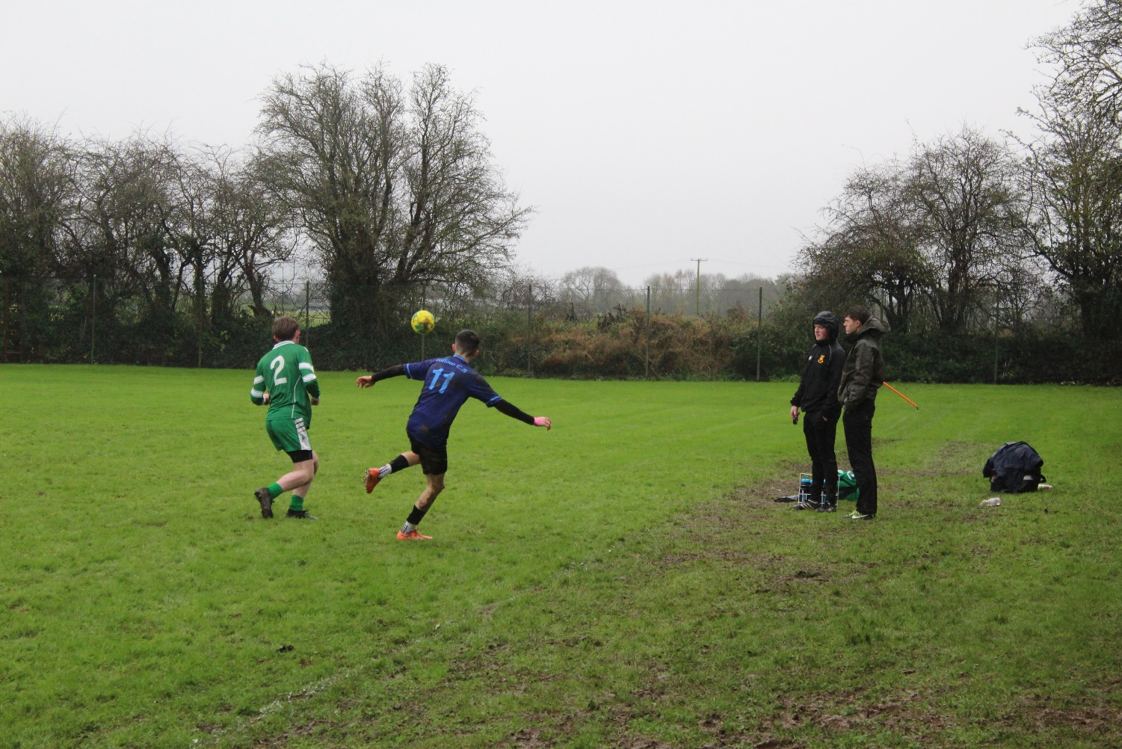

The second half started as the first half had finished with Tullow trying to press home their advantage and Callum Murray nearly increased the lead within minutes of the restart. Jamie Maher who had been looking dangerous in front of goal throughout the game again tested the Baltinglass keeper after 9 minutes of the second half.

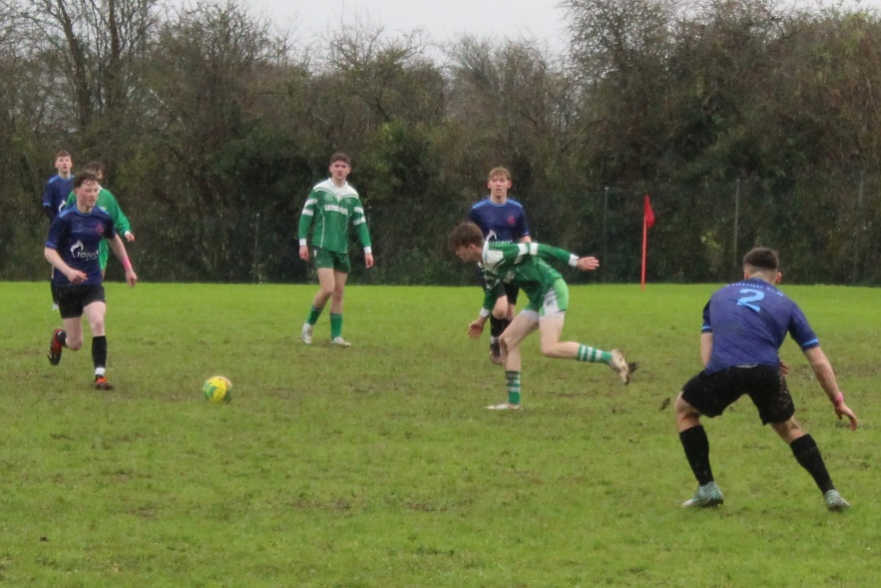

Mr O’Reilly rang the changes to keep fresh legs when Daragh Corcoran and Eddie Hourihane came on for Oisin Nolan and Jamie Maher in the 13 minute. This proved to be an inspirational switch as and a goal by Daragh Corcoran with a rocket shot in the 14th minute made the score 3-1 to Tullow.

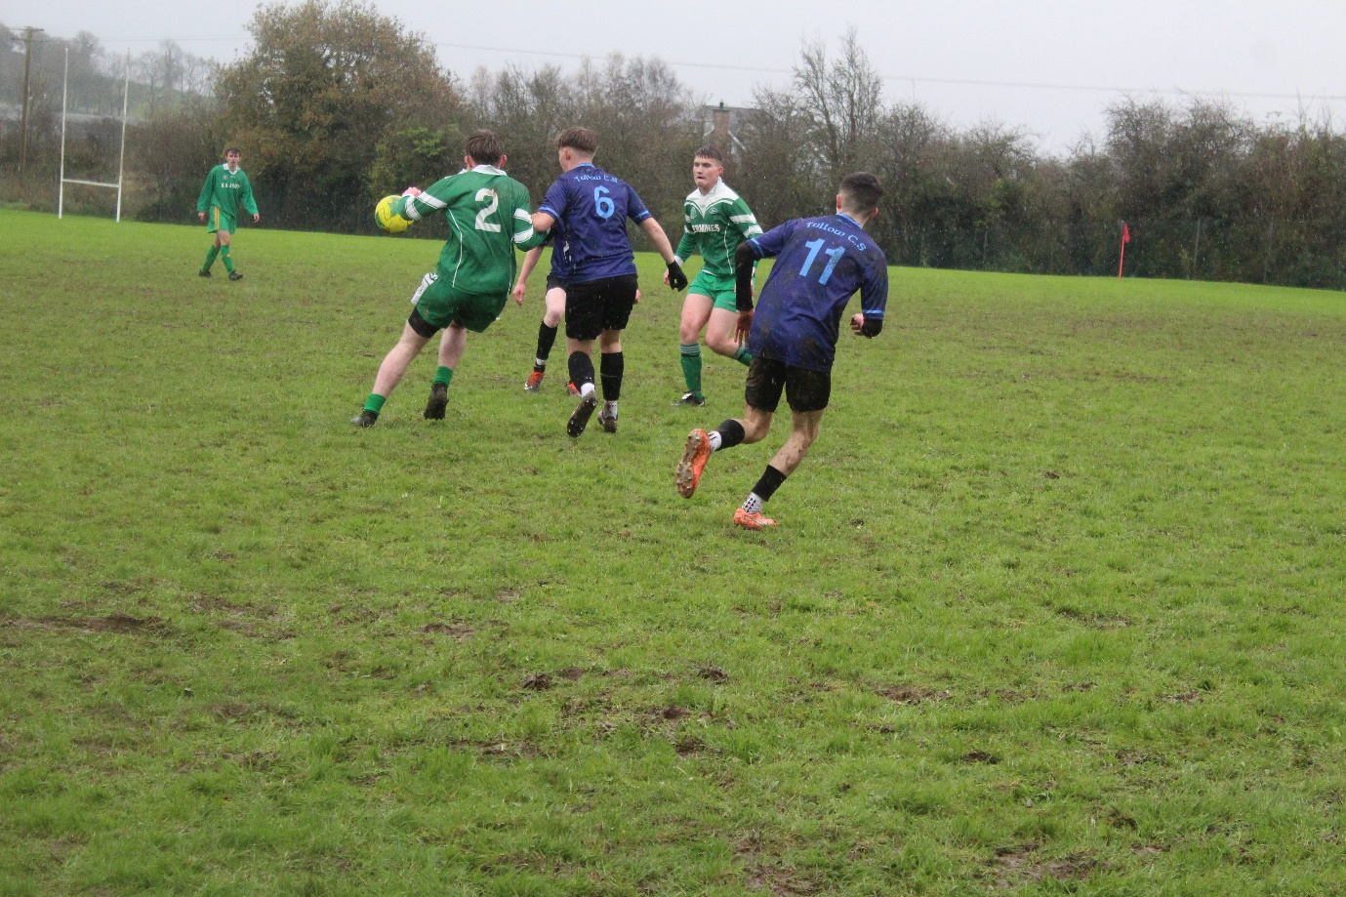

Brin Nolan and Niall O’Byrne took to the field for Callum Murray and Daniel Whelan in the 25th minute. There was a ray of hope for Baltinglass 5 minutes later when they were awarded a penalty. In the turning point of the game TCS keeper Dylan Cunningham pulled off a massive save from the spot kick to keep the two goal lead in tack.

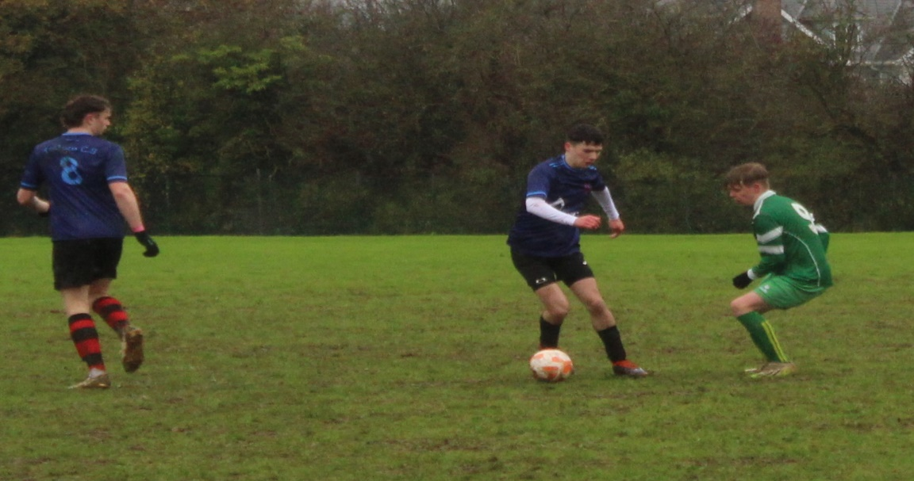

As the game approached the last quarter Tullow pressed home their advantage with a wonderful Aaron Dowling goal in the 31st minute to make the score 4-1. TCS continued to press on and super sub Daragh Corcoran was on hand again in the last few minutes to score his second goal of the half and leave Tullow with a 5-1 lead that they seen out to the final whistle. Well done to all players & coaches involved and TCS now head into their final game with a 100% record.