# **Logo, icon Description automatically generatedLogo, company name Description automatically generatedTUllOw C.s Match report**

TCS U19 Boys make it two from two!!

***Reporting by: Joseph Waters , Daniel O Brian & Patrick O’Toole Active School Flag Reporting Team***

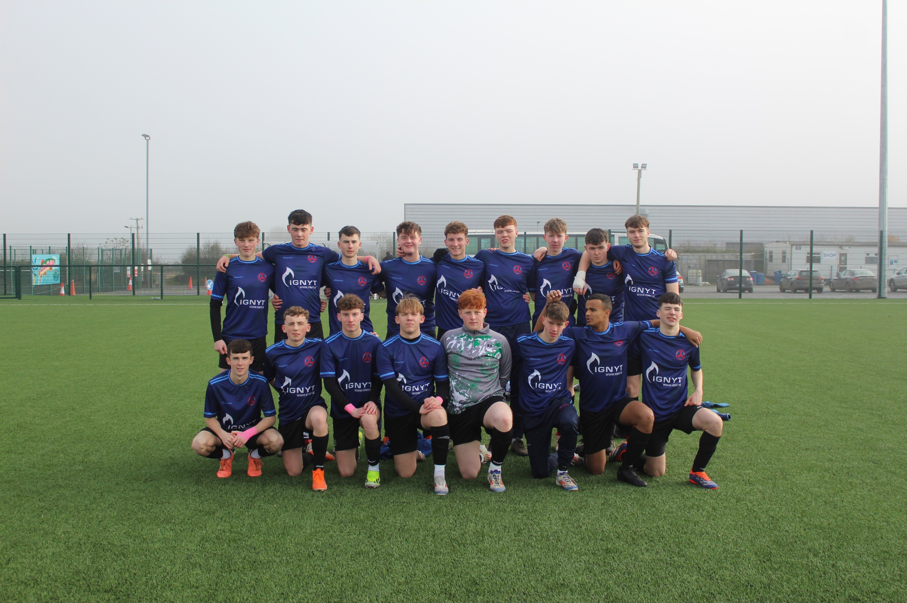

On Thursday the 12th of November the Tullow CS Under 19 Boys Soccer team travelled down to the Thomastown Astro turf pitch to take on Grennan College. The game kicked off with both teams looking like they were willing to play free flowing attacking football. Grennan were the first to strike in the 10th minute after a swift attack caught the Tullow defence napping to score a well worked goal. Tullow were determined to stick to the game plan with Johnny Maher coming close to levelling the scores within minutes with a great effort.

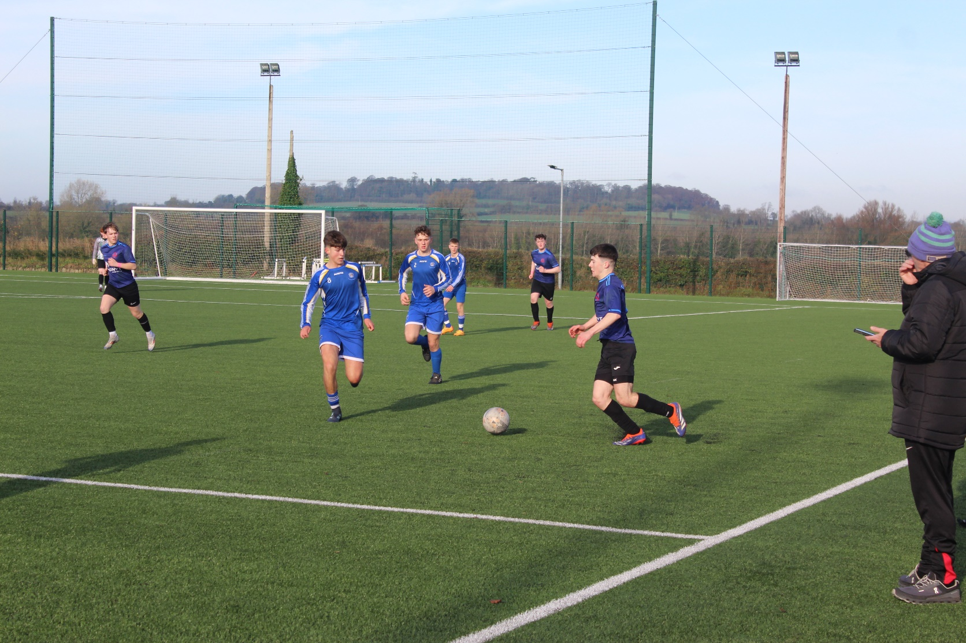

The game was really flowing back and forth at this stage, Tullow had a lucky escape when a foul just outside their box lead to a dangerous Grennan freekick which when narrowly over the bar. It was Tullow who went close next when Dean Keogh making use of the ball gets past the Grennan midfield and takes a shot which unfortunately goes narrowly wide. The Tullow pressure soon paid dividend do when a well worked passage of play seen Aaron Dowling get hold of the ball inside the box and fired home a curling effort to level the score at 1-1.

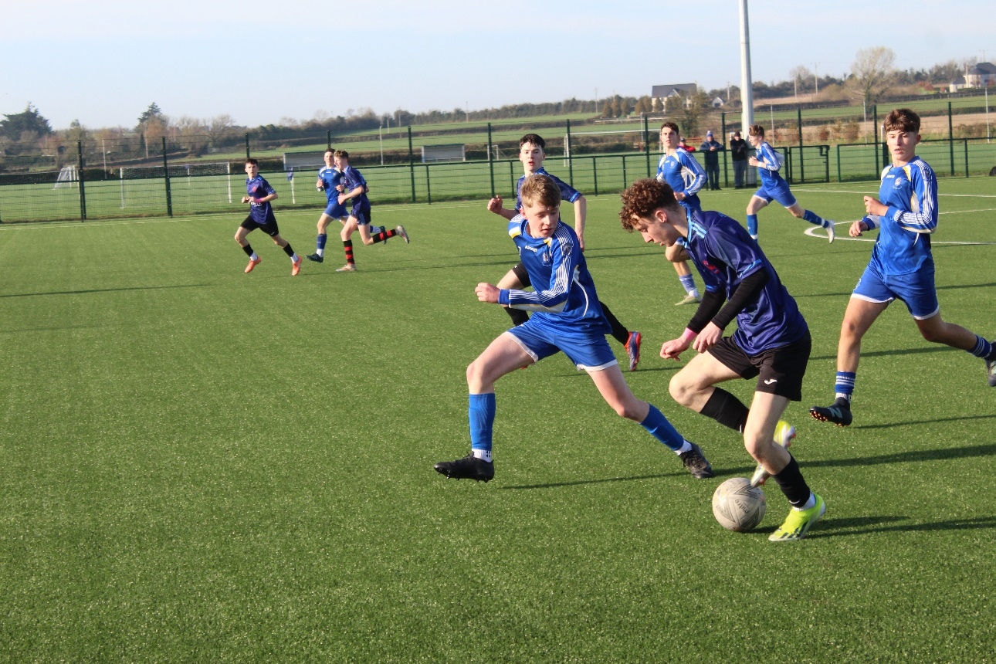

Tullow’s confidence was really growing now as they played their way into the game. An amazing attacking move between Adam Dowling and Callum Murray seen Tullow break from midfield and a quick one two put Callum Murray through on goal to calmly slide the ball into the Grennan net making it 2-1 to Tullow 20 minutes in. The next 20 minutes were quiet with both teams passing the ball well and maintaining large spells of possession before half time to leave the score 2-1 to Tullow.

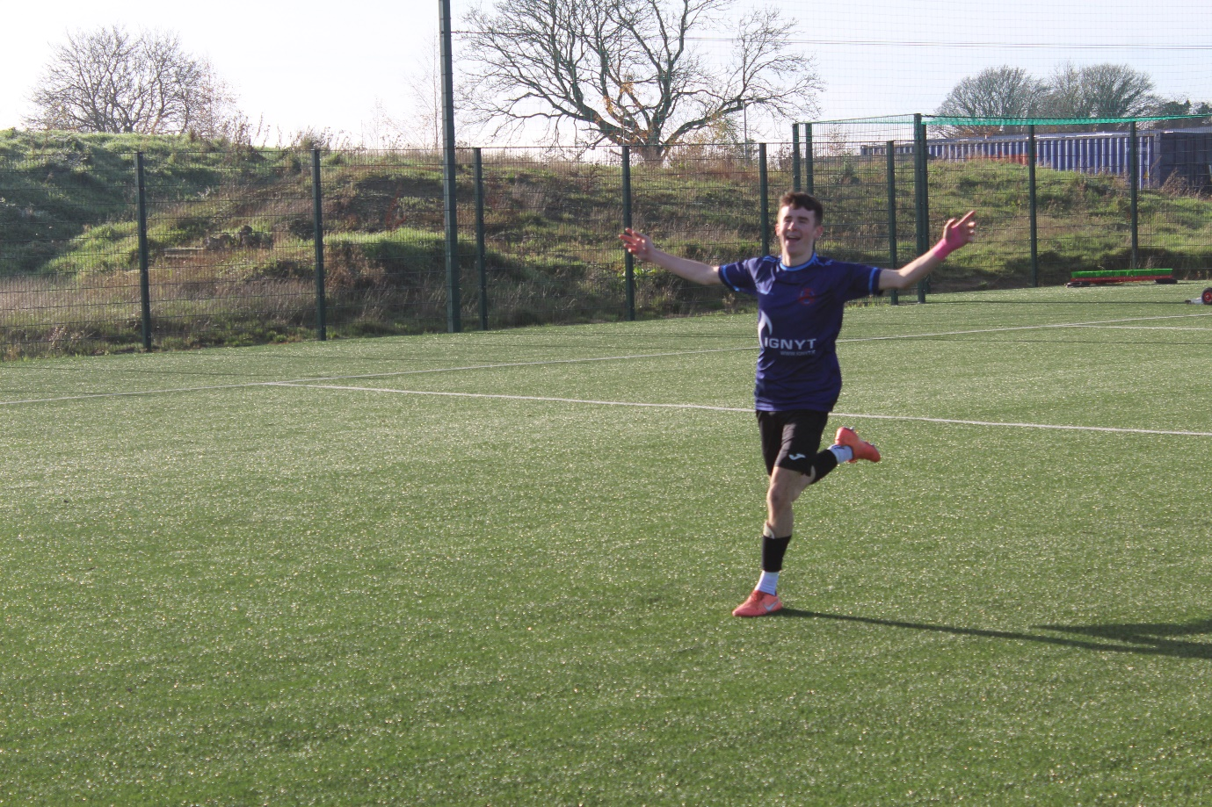

The second half kicks off with Grennan not wasting any time to get on the front foot. They moved well up through the field before being fouled on the box and set up a freekick in a dangerous position. Unbelievably Grennan scored the free kick making it 2-2 with 7 minutes gone in the second half. Tullow didn’t let their heads drop and straight away got themselves back in front when Daniel Whelan makes a good play down the line crossing to Adam Cleary who flicked the cross onto the head of the ongoing Jamie Maher who was in a great position to head it into the net to make it 3-2 . Tullow were on top now and were denied a fourth goal when an Aaron Dowling gets hold of a true ball and scores but referee controversially calls it offside.

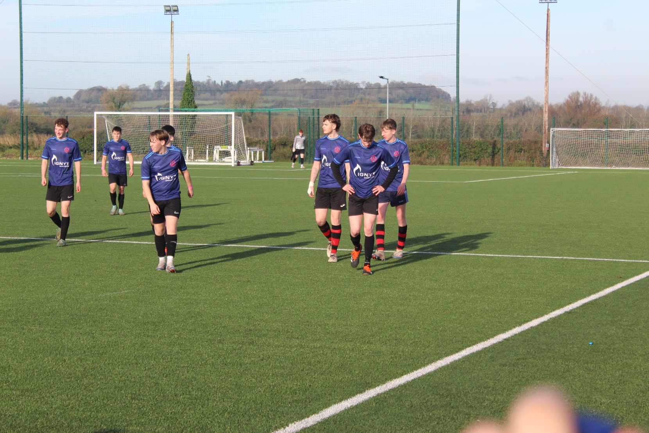

TCS rolled the bench as the second half was coming to a close to keep fresh legs on the field with Callum Murray coming off for Darragh Corcoran. Darragh nearly made an instant impact when he gets hold of the ball but missed a glorious chance. Grennan pressed hard as the game came to a close and TCS had to call on an outstanding save from goalie Dylan Cunningham to keep them in the lead. After a tense final few minutes the game eventually ended on a score line of 3-2 in Tullow CS. Well done to all players & coaches involved in what was a brilliant attacking game of football.

